Madeline Hunter's ITIP model for direct instruction

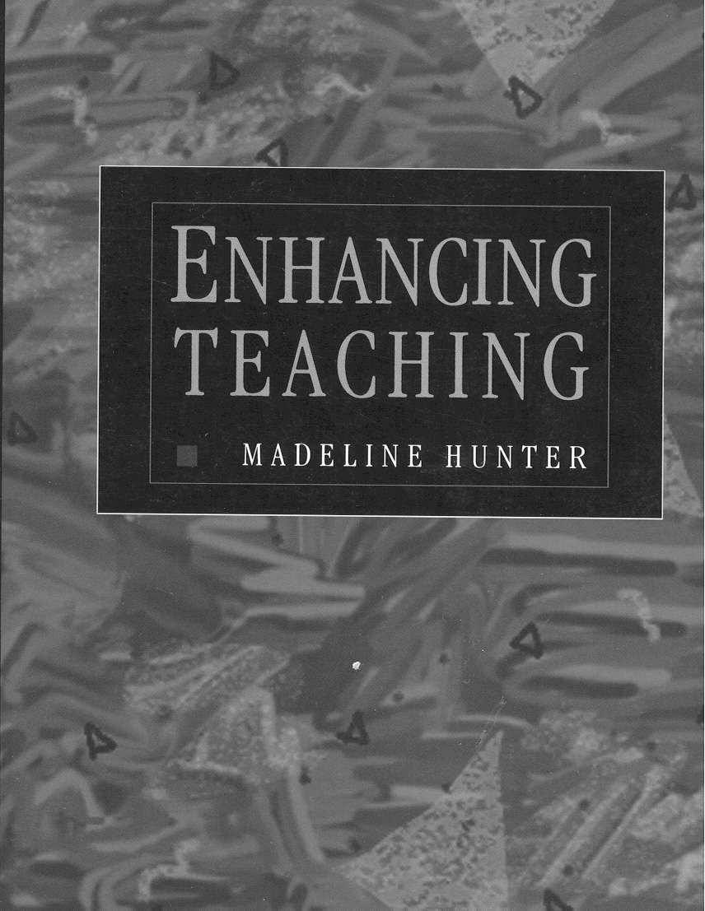
Madeline Hunter developed a teacher "decision-making" model for planning instruction. Her model is called ITIP (Instructional Theory into Practice) and is widely used in school districts around the country and in Michigan. There are three categories which are considered basic to ITIP lesson design.
1. Content: Within the context of grade level, content standards, student ability/needs, and rationale for teaching, the teacher decides what content to teach.
2. Learner Behaviors: Teachers must decide what students will do (a) to learn and (b) to demonstrate that they have learned.
3. Teacher Behaviors: Teachers must decide which "research-based" teaching principles and strategies will most effectively promote learning for their students.
When using Direct Instruction (DI) as the Framework for planning, the teacher increases his/her effectiveness by considering the following seven elements as they "bring alive" the content or as they "scaffold" the learning needs of the students. Teacher decision making is the basis of this approach to teaching. "Decide, then design" is the foundation on which all successful instruction is built.
The following excerpts are taken from "Planning for Effective Instruction: Lesson Design" in Enhancing Teaching by Madeline Hunter, 1994, pp. 87-95.
When designing lessons, the teacher needs to consider the seven elements in a certain order since each element is derived from and has a relationship to previous elements. Also a decision must be made about inclusion or exclusion of each element in the final design--NOT ALL SEVEN ELEMENTS WILL BE INCLUDED IN EVERY LESSON. It may take several lessons before students are ready for guided and/or independent practice. When this design framework is implemented in teaching, the sequence of the elements a teacher includes is determined by his/her professional judgment.
1. (Learning Objective) Select an objective at an appropriate level of difficulty and complexity, as determined through a task analysis, diagnostic testing, and/or congruence with Bloom's cognitive taxonomy.
2. (Anticipatory Set) Motivate instruction by focusing the learning task, its importance, or the prior knowledge/experience of the learners.
3. State the lesson objective(s) to the students.
4. (Input) Identify and teach main concepts and skills, emphasizing clear explanations, frequent use of examples and/or diagrams, and invite active student participation.
5. Check for understanding by observing and interpreting student reactions (active interest, boredom) and by frequent formative evaluations with immediate feedback. Adjust instruction as needed and reteach if necessary.
6. Provide guided practice following instruction by having students answer questions, discuss with one another, demonstrate skills, or solve problems. Give immediate feedback and reteach if necessary.
7. Assign independent practice to solidify skills and knowledge when students have demonstrated understanding.
The following questions are from Madeline Hunter and can guide you in making teaching decisions.
1. What Instructional Input Is Needed?
All lesson design begins with articulation of an instructional objective. It specifies the perceivable student behavior that validates achievement of the precise content or process or skill that is to be the learning outcome. To plan the instructional input needed to achieve the "target objective," the teacher must determine what information (new or already possessed) the student needs in order to accomplish the intended outcome. Students should not be expected to achieve an objective without having the opportunity to learn what is essential in order for them to succeed. Task analysis is the process by which the teacher identifies the component learnings or skills essential to the accomplishment of an objective. Once the necessary information, process, or skill has been identified, the teacher needs to select the means for "getting it in students' heads." Will it be done by discovery, inquiry, teacher presentation, book, film, record, filmstrip, field trip, diagram, picture, real objects, demonstration? Will it be done individually, collaboratively, or in a larger group? The possibilities are legion, and there is no one way that is always best.
Examples:
** The teacher explains.
** A film is used to give information or demonstrate an activity.
** Students use library resources.
** Students discover the information by doing laboratory experiments or field observations.

2. What Type of Modeling Will Be Most Effective?
It helps students to not only to know about something, but to also see or hear examples of an acceptable finished product (a story, poem, model, diagram, graph), or to observe a person's actions or hear him talk-aloud about how he decided to perform a task (how to identify the main idea, or determine ways of thinking or making decisions while completing the assignment).
It is important that the visual input of modeling be accompanied by the verbal input of labeling the critical elements of what is happening (or has happened) so that students are focused on essentials rather than being distracted by transitory or nonrelevant factors in the process or product.
Examples:
** "I am going to use my thumb to work the clay in here like this so the tail has a firm foundation where it is joined to the body of the animal. In that way, it's less likely to break off in the kiln." (art instruction)
** "While I do this problem, I'll tell you what I'm thinking as I work." (math talk-aloud strategy)
** "Notice that this story has a provocative introductory paragraph that catches your interest by the first question the author asks." (literature instruction)
In lessons designed to produce divergent thinking or creativity, a teacher usually should not model because students will tend to imitate. The modeling should have occurred in previous lessons so that the students have acquired a repertoire of alternatives from which they synthesize an outcome satisfying to them--thereby being creative in their responses to the assignment.
3. How Will I Check for Understanding?
The teacher needs to know at what point students possess the information and/or skill necessary to achieve the instructional objective. The following are some ways of determining when and how:
Sampling
Sampling means posing questions to the total group, allowing them time to think, and then calling on class members representative of the ability strata of the group (most able, average, least able). This process focuses everyone on the generation of an answer and develops student readiness to hear an affirmation or challenge of his/her answer. Note that at the beginning of learning, correct answers are most enabling. Therefore, it is recommended that the teacher at first call on able students to avoid incorrect answers, which can "pollute" the learning that results from this approach.
Examples: State the question or give the direction, then give thinking time before naming a student to respond:
** "Be ready to summarize the results of ______."
** "What do you believe were the reasons that Washington was a great leader? I'll give you a minute to think."
** "How would you estimate the answer?"
** "What commonalities do you see?"
Signaled Responses
Each member of the group makes a response, using a signal. For example, students show their selection of the first, second, third, or fourth alternative by showing that number of fingers, put a pencil straight up for "don't call on me for this question," make a c with a hand when examples correct or an i when incorrect. Math operations, first letters of words, and punctuation all can be hand-signaled. Nodding or shaking of heads, use of counting sticks, and pointing to a place in the book or to parts in a diagram or to objects are examples of the many signals that can validate learning, or lack of it, for each member of the group.
Examples:
** "Nod your head if you agree. Shake your head if you don't.'
** "Signal whether you add, subtract, multiply, or divide, by making that sign with your fingers."
** "Show a c with your fingers if what I say is correct; an i if incorrect. Don't do anything if you're not sure."
** " Raise your hand when you are ready to answer this question."
** "On your microscope, point to _______."
Group Choral Response
After the teacher presents a question to the total group and gives thinking time, the strength of a choral response can indicate the general degree of student accuracy and comfort with the learning. However, this method usually does not give information about individuals.
Individual Private Response
A brief written or whispered-to-teacher response (when the teacher is moving about the room from desk to desk, table to table) makes students accountable for demonstrating possession of, or progress toward, achievement of the needed information or skills.
Examples:
** "Write the names of the three important categories we have discussed and one example within each."
** "Do the first part of this problem on your paper."
** "As I walk around, be ready to tell me your topic and the main idea of your paper."
4. How Will I Design Guided/Monitored Practice?
The beginning stages of learning are critical in the determination of future successful performance. Initial errors can become "set" and be difficult to eradicate--called misconceptions. Consequently, students' initial attempts in new learning should be carefully monitored and, when necessary, guided so they are accurate and successful. Teachers need to practice with the total group or circulate among students to make sure instruction has "taken" before "turning students loose" to practice independently (with no help available). With teacher guidance, the student needs to perform all (or enough) of the task so that clarification or remediation can occur immediately should it be needed. In that way, the teacher is assured that students subsequently perform the task correctly without assistance rather than be practicing errors when working by themselves.
5. What Independent Practice Will Cement the Learning?
Once students can perform with a minimal amount of errors, difficulty, confusion, they are ready to develop fluency, along with increased accuracy, by practicing without the supervision and guidance of the teacher. Only at that point can students be given an assignment to practice the new skill or process with little or no teacher direction.
Teachers, like doctors, are successful only when the student no longer needs them. All teaching has as its purpose to make the student as independent as possible. When lessons are carefully planned, student independence becomes much more probable. It is important that in independent work, the student does what already has been practiced rather than some new, or experimental task. The purpose is for them to build confidence and competence in doing the task.
6. Should the Students Be Made Aware of the Lesson Objective and Its Value?
This element of an effective lesson involves communicating to students what they will learn during the instruction and why that accomplishment is important, useful, and relevant to their present and/or future life situations. It is not just the usual, "At the end of today's lesson you will be able to _______." Remember--not only the what, but the why!
Examples:
** "You were slowed down yesterday because you had trouble with _______. Today we are going to practice in order that you develop more speed and accuracy."
** "We are going to work on the correct form of letter writing so that you can write for the materials you need in your social studies project."
** "Today you are going to practice ways of participating in a discussion so each of you gets turns and you also learn from other people's ideas."
** "You are going to be surprised to find out what happened after Columbus returned and the difference his voyage made to our ways of thinking."
Note that the objective as stated to the student is not as it is stated in the teacher's plan book: "The learner will use correct form in writing a letter"; "The learner will list the results of Columbus voyage and explain their significance."
Usually, students will learn more efficiently if they know what the learning will be and why it is important in their lives. There are times, however, when the objective should not be known because it will distract them or turn them off. ("Today you are going to learn the difference between colons and semicolons" could elicit a "Who cares?")
7. What Anticipatory Set Will Focus Students on the Objective?
An "Anticipatory Set" results from a brief activity that occurs at the beginning of the lesson or when students are mentally "shifting" gears from one activity to the next. The purpose of an anticipatory set is to elicit students' attending behavior, focus them on the content of the instruction to follow, and help them develop a mental readiness (or "set") for it. The "set" may (but doesn't need to) include a review of previous learning if it will help the student achieve today's objective, but not routine review of old material. The set also may give the teacher some diagnostic data needed for teaching the current objective.
An anticipatory set activity should continue only long enough to get students "ready and set to go," so that the major portion of instructional time is available for the accomplishment of the current objective.
Examples: Examples of activities that produce an anticipatory set are having students--
** Give synonyms for overused words, when the current objective is improvement in descriptive writing
** Create word problems to go with a numeral problem on the chalkboard, when the current objective is meaningful computation practice
** Review the main ideas of yesterday's lesson, which will be extended today
** State ways a skill might be useful in daily life, when the objective is to develop fluency with that skill
** Practice speedy answers to multiplication facts for a quick review before today's math lesson on two-place multiplication
An anticipatory set is not needed if students are already alert and "ready to go" because yesterday's teaching built a bridge or transition to today's lesson.
Summary -- a reminder....
Not all the ITIP seven elements just described will be included in every lesson. It may take several lessons before students are ready for guided and/or independent practice. Also, mere presence of an element in a lesson does not guarantee quality teaching. A teacher may use an anticipatory set that spreads rather than focuses students' attention ("Think of your favorite food; today we are going to talk about cereals"). Input may be done ineffectively. The modeling may be distracting ("I will cut this chocolate cupcake in fourths"). The seven elements are guides in planning for creative and effective lessons. They are not mandates!
Simply "knowing" the seven elements of planning for effective instruction will not ensure that those elements are implemented effectively. Also, simply having a "knack with kids" will not ensure the elements that promote successful learning will be included in instructional planning. Both the science and the art of teaching are essential. It is Madeline Hunter's belief, however, that deliberate consideration of these seven elements, which can promote effective instruction, constitutes the launching pad for planning effective and artistic teaching (using any model of teaching with any type of student) to achieve greater student achievement of any objective or goal.
Regardless of the teaching model, student success results from careful planning of how to bring the standards alive, and through artistic implementation of the plan!!!!.
Bibliography
Brown, D. S. (1988). Twelve middle-school teachers planning. The Elementary School Journal, 89(l), 69-87.
Condon, D., & Maggs, A. (I986). Direct instruction research: An international focus. International Journal of Special Education, 1, 35-47.
Doyle, W. (1984). Effective classroom practices for secondary schools. R & D Report No. 619 1. Austin: Texas University Research and Development Center for Teacher Education.
Gagne, E. D. (I985). Strategies for effective teaching and learning. In The cognitive psychology of school learning. Boston: Little, Brown.
Gagne, R. M., & Briggs, L. J. (I 974). Principles of instructional design. New York: Holt, Rinehart & Winston.
Gerston, R. (1986). Direct instruction: A research-based approach to curriculum design and teaching. Exceptional Children, 53, 17-3 1.
Kallison, J. M. (I986). Effects of lesson organization on achievement. American Educational Research Journal, 23(2), 337-347.
Moore, J. (I986). Direct instruction: A model of instructional design. Educational Psychology, 6, 201-229.
Pratton, J., & Hates, L. W. (I985). The effects of active participation on student learning. Journal of Educational Research, 79, 210-215.
Rosenshine, B., & Stevens, R. (I986). Teaching functions. In M. C. Wittrock (Ed.), Handbook of Research on Training (3rd ed., pp. 3 75-3 9 1). New York: Macmillan.
http://www.hope.edu/academic/education/wessman/2block/unit4/hunter2.htm

